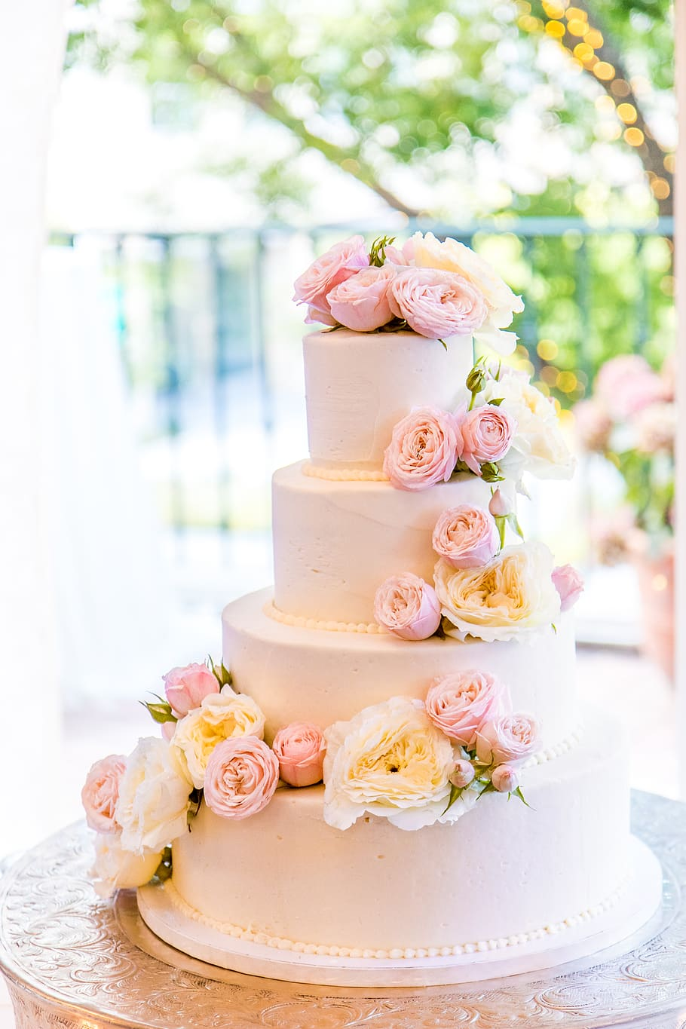 Happy Birthday

Anjali Pathak

Many – Many Happy

Return of the day.

My best wishes for a furious and

Voracious day filled with plenty

Of smile and laughter

Birthday Date= 10/August/2007